Software Requirements Specification

for

Fitness Activity Tracker (FAT)

Version 1.0

Prepared by

Group Name: The Great Unwashed

|  |  |
| --- | --- |
| Jillian Cleek | jrc064@shsu.edu |
| Quan Do | qcd002@shsu.edu |
| Arieus Green | alg045@shsu.edu |
| Deantrey Loche | dfl005@shsu.edu |
| Christopher Noack | cmn009@shsu.edu |
| Jay Pruett | jay_pruett@shsu.edu |
| Nicholette Schaefer | nas017@shsu.edu |
| Robby Simons | rrs018@shsu.edu |
| Colin Williamson | cmw042@shsu.edu |

|  |  |
| --- | --- |
| Instructor: | Dr. David Burris |
| Course: | Software Engineering |
| Lab Section: | *COSC 4319.01* |
| Date: | February 15, 2013 |

Contents

Revisions 3

1 Introduction 3

1.1 Document Purpose 3

1.2 Product Scope 3

1.3 Intended Audience and Document Overview 3

1.4 Definitions, Acronyms and Abbreviations 3

1.5 References and Acknowledgments 4

2 Overall Description 5

2.1 Product Perspective 5

2.2 Product Functionality 5

2.3 Users and Characteristics 7

2.4 Operating Environment 7

2.5 Design and Implementation Constraints 7

2.6 User Documentation 7

2.7 Assumptions and Dependencies 7

3 Specific Requirements 8

3.1 External Interface Requirements 8

3.2 Server Infrastructure 16

3.3 Database Infrastructure 17

Appendix A - Group Log 18

Revisions

| Version | Primary Author(s) | Description of Version | Date Completed |
| --- | --- | --- | --- |
| N/A | N/A | N/A | N/A |

# 

# Introduction

## Document Purpose

The purpose of this document, presented by The Great Unwashed, is to provide users, potential customers, and developers with a detailed overview of an upcoming application named Fitness Activity Tracker (FAT). This document explains the functionality, general use, and integrated features that are assimilated into the application. The release date of FAT is projected to be April 19th, 2013.

## Product Scope

FAT was designed to help track and aid users in reaching their individual fitness goals. The use of quantitative attributes and universal equations will calculate general health statistics and tailored results. FAT will incorporate a relational database of tables that can be updated via the user interface. The ultimate goal of this application is to increase the overall health and fitness awareness of the population at large.

## Intended Audience and Document Overview

Readers with technical backgrounds will have no problem understanding the entirety of the document. General users will find the information over basic functionalities beneficial to the overall use of the application. If any uncertainties arise, please refer to the screenshot section for clarification.

## Definitions, Acronyms and Abbreviations

Activity Levels:

Sedentary – little or no exercise

Lightly Active – light exercise (workout 1-3 days per week)

Moderately Active – moderate exercise (workout 3-5 days per week)

Very Active – hard exercise (workout 6-7 days per week)

Extremely Active – hard daily exercise (workout and physical job or 2 * day training)

Age – the user’s age in years

Body Measurements:

Biceps (inches)

Chest (inches)

Neck (inches)

Shoulders (inches)

Thighs (inches)

Waist (inches)

BMI – Body Mass Index

BMR – Basal Metabolic Rate

Duration – time in minutes

Height – the user’s height in inches

HR – heart rate

Ideal Heart Rate – target heart rate during exercise

Maintenance Calories – daily calorie consumption to maintain current weight

User - anyone who wishes to view the application

Weight – user’s weight in pounds

## References and Acknowledgments

Activity Levels - http://www.shapefit.com/basal-metabolic-rate.html

BMI Formula - http://www.freebmicalculator.net/calculate-bmi.php

BMR Formula - http://www.healthfitonline.com/resources/harris_benedict.php

Calories Burned Formula - http://www.shapefit.com/basal-metabolic-rate.html

HR Range Formula - http://my.clevelandclinic.org/heart/prevention/exercise/pulsethr.aspx

IEEE STD. 830-1998, IEEE Recommended Practice for Software Requirements Specifications

Three-Tier Architecture Image -

http://www.softwaretestingclass.com/wp-content/uploads/2013/01/three-tier-architecture.png

# Overall Description

## Product Perspective

FAT is a newly developed, self-contained application. This application is part of a three-tier system that utilizes an Android based Graphical User Interface (GUI), a server, and a relational database. The use of this application is restricted solely to the Android user base. This decision was constructed due to the growing popularity of the Android based operating system and expanding user population.

### three-tier-architectureSystem Interfaces

## FAT implements a three-tier architecture which contains a relational database, web server, and a client model. The database contains the tables Exercises, Food, and UserInfo. All of the tables will be related by the Total Calorie calculated value. The server will act as a mediator between the client model and the database allowing for the exchange of information. Users will interact with the client model while providing them with limited, but sufficient, access to information in the database.

## Product Functionality

Some of the major functions of FAT allows users to:

* Maintain personal health measures in their own password protected account
* Record and track calories
* Monitor food consumption
* Establish personal fitness goals
* View nutrition facts
* Real time communication via social media

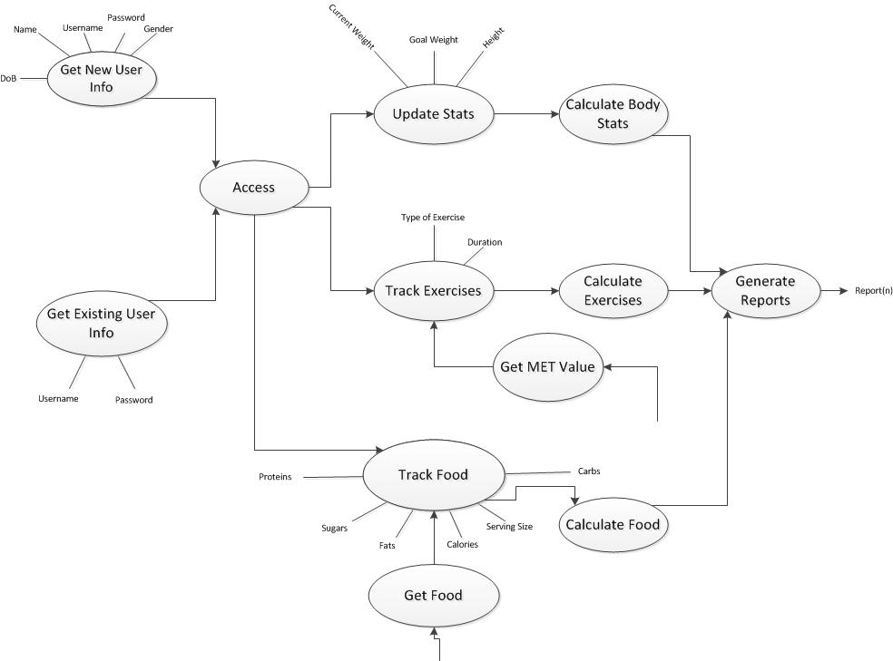**Data Flow Diagram**

## Users and Characteristics

The users are people who download and proceed to use the application. All users are granted the same limited privileges. The backgrounds of the users are expected to range from novice to technological connoisseurs.

## Operating Environment

FAT is being developed for use on the Android operating system. Future updates will enable this application to be used on other devices/operating systems.

## Design and Implementation Constraints

No constraints have been recognized at this time.

## User Documentation

New users of FAT will be provided with a one-time pop-up tutorial of the major components and features. If the user wants to reference back to the tutorial, there will be an option to do so.

## Assumptions and Dependencies

No assumptions or dependencies at this time.

# Specific Requirements

## External Interface Requirements

### User Interfaces

* **Login**
  + The user will be able to enter a unique user name
    - Each username will have an associated user-defined password
  + The user will be able to create a new account if they don’t have one
    - The user will be redirected to the New User Screen
  + The user will be able to recover a password
    - The user will need to provide email address to reset forgotten password
  + Once username and password are authenticated, the user will be granted access to the application and their account
* **New User**
  + The user will be able to generate a unique username
  + The user will have to make and confirm a password
  + The user will enter in personal information to complete their account
    - After completion, the user will be sent to the Login Screen
* **Home**
  + The user’s remaining calories for the day will be displayed on this screen
  + The new user will be guided through a tutorial for first time login
    - This will explain to them on how to update their health statistics
  + The user will be able to select a Track Food button
    - This will direct the user to the Track Food screen
  + The user will be able to select an Exercises button
    - This will direct the user to the Exercises screen
  + The user will be able to select an Update Stats button
    - This will direct the user to the Update Stats screen
  + The user will be able to select a View Stats button
    - This will direct the user to the View Stats screen
  + The user will be able to select an Account button
    - This will direct the user to the Account information screen
  + The user will be able to select a Help button
    - This will direct the user to the Help screen
  + The user will be able to post progress/achievements on social media outlets
* **Track Food**
  + The user will be able to track nutrition facts
    - The user will be able to select food existing in the database
    - The user will be able to input nutritional facts for food not found in the database
  + The user will be able to update remaining daily calories
  + The user will have the ability to return Home
* **Track Exercises**
  + The user will be able to track calories burned from exercise
    - The user will select exercise type from list given
    - The user will enter the duration of the exercise
    - The user will see the resulting calories burned
      * Calories burned will be derived from: (Weight * MET * 3.5 * Duration) / 200
  + The user will have the ability to return Home
* **Update Stats**
  + The user will be able to update individualized goals/measurements
    - The user will be able to update current weight, goal weight, height, and body measurements.
    - The user will be able to select/modify activity level
      * Activity levels include: Sedentary, Lightly Active, Moderately Active, Very Active, Extremely Active
  + The user will have the ability to return Home
* **View Stats**
  + The use will be able to view current individual statistics
    - These user will be able to view current weight
    - The user will be able to view goal weight
    - The user will be able to view maintenance calories
      * BMR is calculated using the Harris Benedict Equation
        + For men: BMR= 66 + (6.23 * weight) + (12.7 * height) – (6.8 * age)
        + For women: BMR= 655 + (4.35 * weight) + (4.7 * height) – (4.7 * age)
      * Once the BMR is found it is multiplied by activity level
        + Sedentary = BMR * 1.2
        + Lightly Active = BMR * 1.375
        + Moderately Active = BMR * 1.55
        + Very Active = BMR * 1.725
        + Extremely Active = BMR * 1.9
    - The user will be able to view current activity level
    - The user will be able to view current BMI
      * The formula for BMI is:
        + BMI = (weight/height2) * 703
    - The user will be able to view current BMI status
      * Statuses include:
        + Underweight
        + Ideal
        + Overweight
        + Obese
        + Very Obese
    - The user will be able to view ideal exercising heart range
      * The formula for target HR is:
        + {(220-age) * 0.6} ~ {(220-age) * 0.8}
    - The user will have the ability to return Home
* **Account**
  + The user will be able to update account information
    - The user will be able to update name
    - The user will be able to update email
    - The user will be able to update password
* **Help** 
  + The user will have the ability to review the tutorial
  + The user will have the ability to view terminology

**Screenshots**

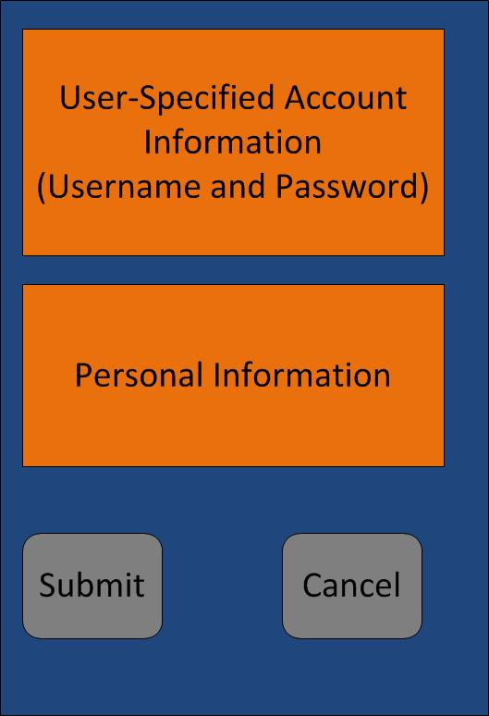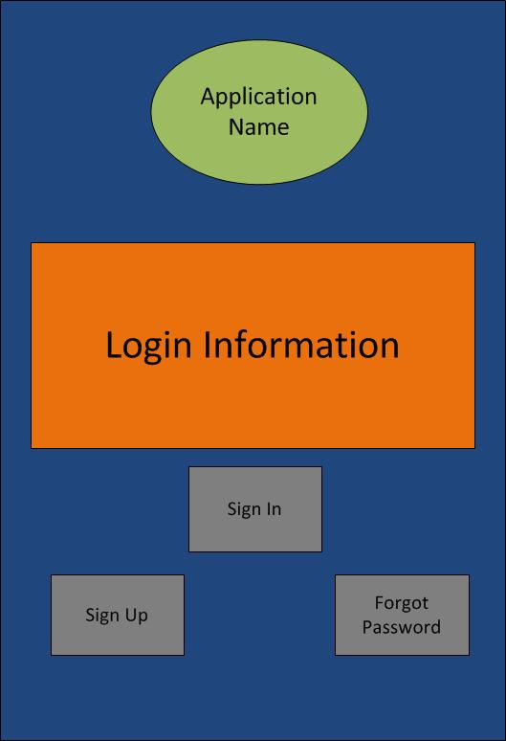

Create Account Screen

Main Login Screen

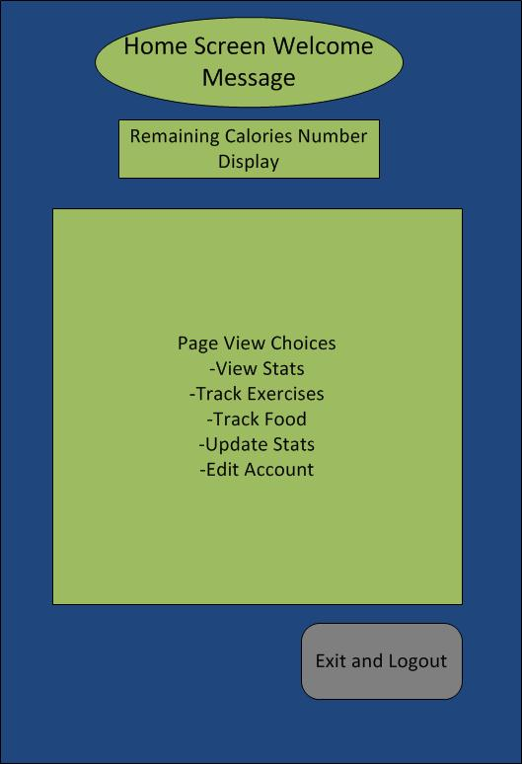

Help Screen

Main Application Screen

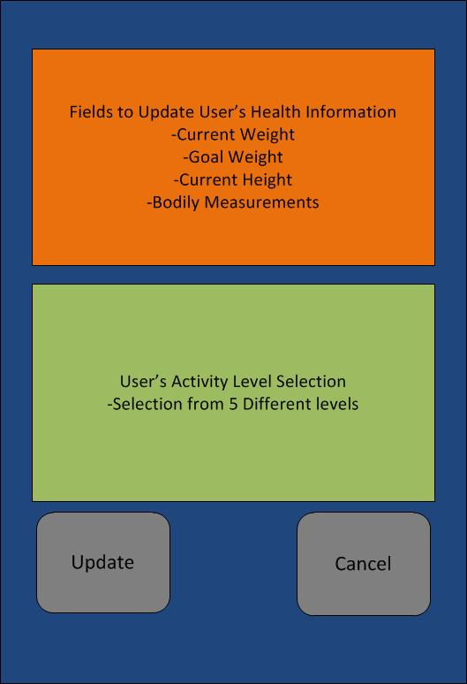

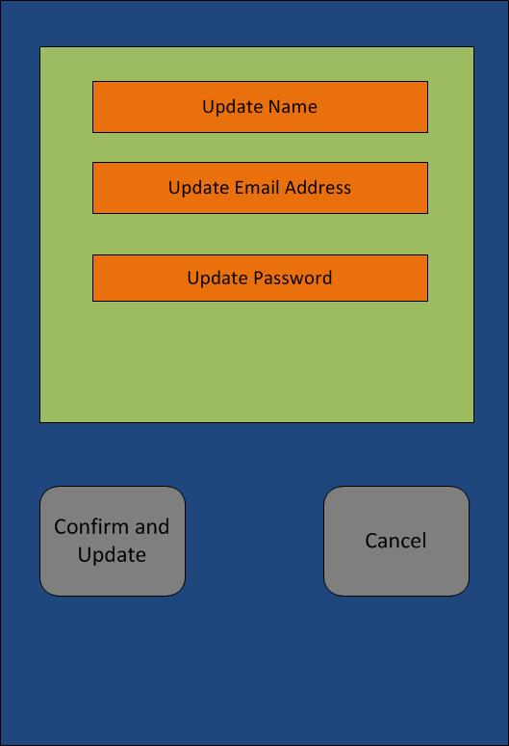

Update Stats Screen

Edit Account Screen

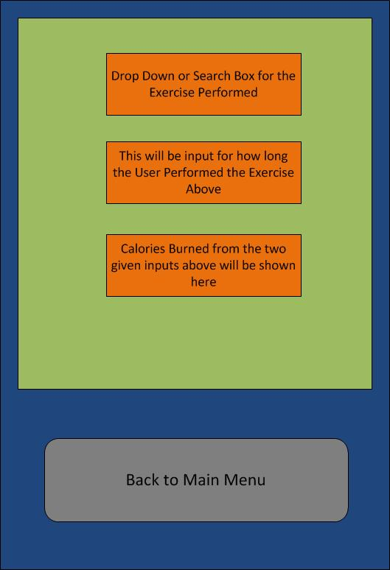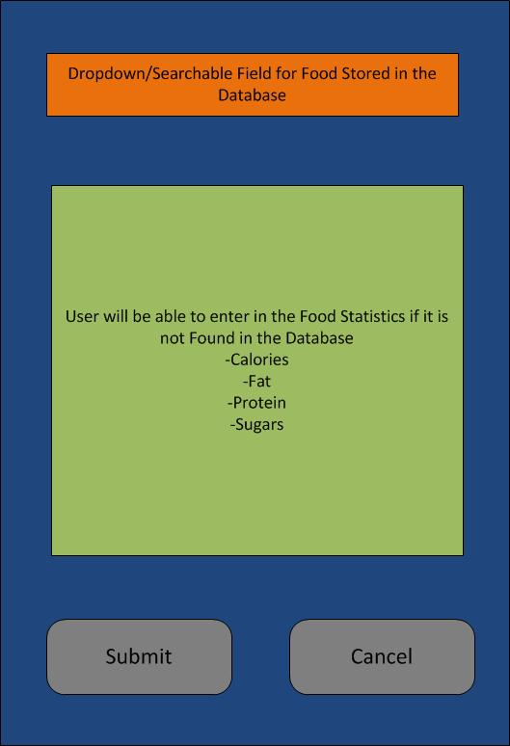

Exercise Screen

Food Screen

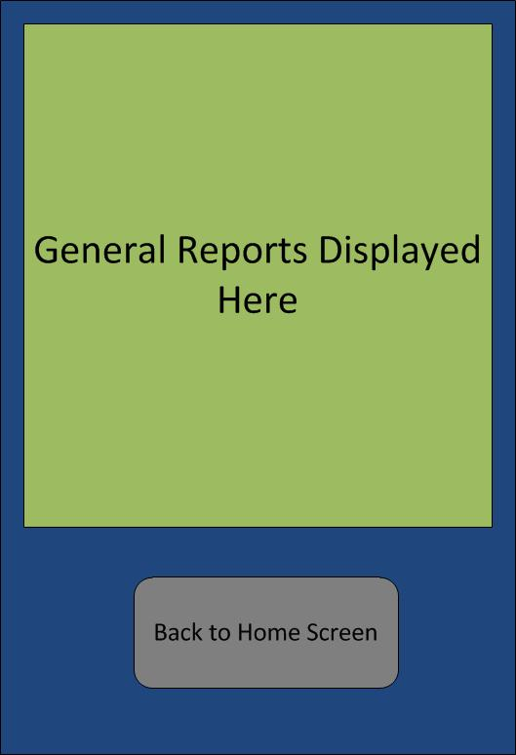

Report Screen

### Software Interfaces

There are no constraints at this time. This will be decided by the design team during the design phase.

### Communications Interfaces

There are no constraints at this time. This will be decided by the design team during the design phase.

## Server Infrastructure

* **Server shall be Virtualized**
  + Server will reside on Hyper-Visor
  + Server will be integrated into Failover Cluster
* **Server will have multiple access methods**
  + Server will be accessible via console
  + Server will have administrative functions from console
  + Console will be able to perform commands on host OS
* **Server will be accessible via remote connection**
  + Server will have secure remote connection ability
  + Remote connection will use secure Terminal emulation for access
* **Server shall be accessible by Graphical User Interface**
  + GUI shall use secure channel communications to access server
  + GUI will allow same capabilities as console connection
* **Server shall have active backup routine**
  + Server shall perform monthly full backups automatically
  + Server shall perform continuous incremental backups
  + Server shall implement Volume Shadow Service to allow for continued access
  + Server will backup data to a highly available storage cluster to ensure no loss of data
  + Server shall archive backups in alternate location than primary backups to ensure system redundancies
* **Server shall serve as connection point for user access to database**
  + Server shall host connection for users
  + Server will process access request from users
  + Server shall act as authentication for users

## Database Infrastructure

* **Database shall be responsible for storing all user data in these tables:**
  + **Exercises Table**
    - The following fields will be included: ExerciseName, METValue, TotalCalories
    - The primary key will be ExerciseName
  + **Food Table**
    - The following fields will be included: Fat, Sugars, Proteins, Carbs, FoodName, Calories, TotalCalories
    - The primary key will be FoodName
  + **User Info Table**
    - The following fields will be included: DOB, Name, UserName, Password, Gender, Age, Height, Weight, GoalWeight, BMI, HeartRate, MaintenanceCalories, ActivityLevel, and TotalCalories
    - The primary key will be UserName
  + **Measurements Table**
    - The following fields will be included: name, biceps, chest, neck, shoulders, thigh, waist
    - The primary key will be name
* **Database Management**
  + **Database will be managed by using Database Management Software**
    - Database management Software will be located on server
    - Database Management Software must be run locally on server
    - Access to Database Management Software can be achieved using multiple access methods
    - A username and password will be required for access to Database Management System
* **Database Storage**
  + **Database will be stored on a separate storage device**
    - Storage device will have multiple storage processors to allow for high input and output operations
    - Storage device will have redundant data patch to server for accessibility
    - RAID will be implemented on storage device to allow for data inconsistencies and error detection in data
    - Regular backups of the database will be performed and stored offsite for data redundancy
    - Restore options will be available from storage device for data
    - Storage device will be accessed through user interface
    - Access to storage device will be limited to administrators

Appendix A - Group Log

The Great Unwashed has been meeting on a daily basis anywhere from 2 or 3 in the afternoon to roughly 5 o’clock in the evening. The arrival time of members was based on their class schedules, but everyone arrived on time.